**Basic**

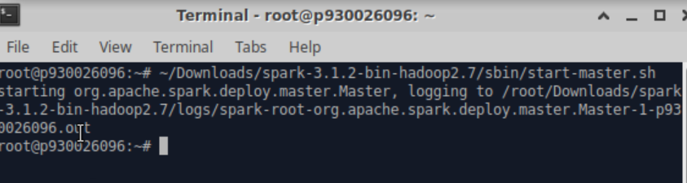

Start the master

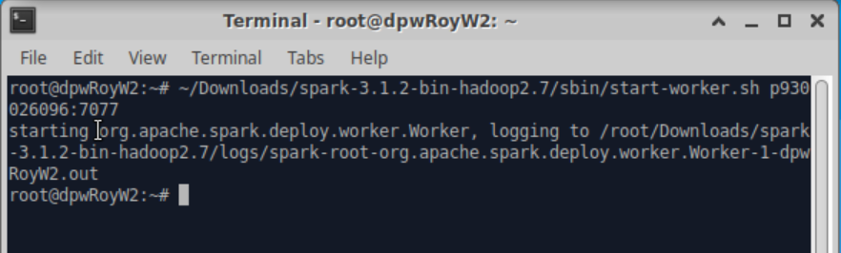

Start the first worker

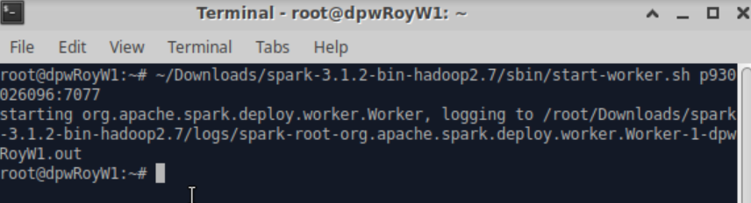

Start the second worker

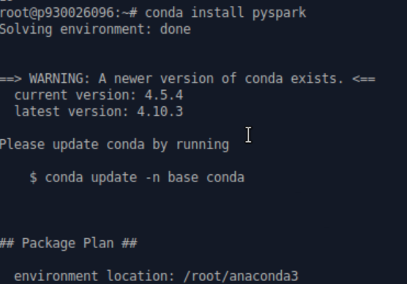

Install pyspark in anaconda

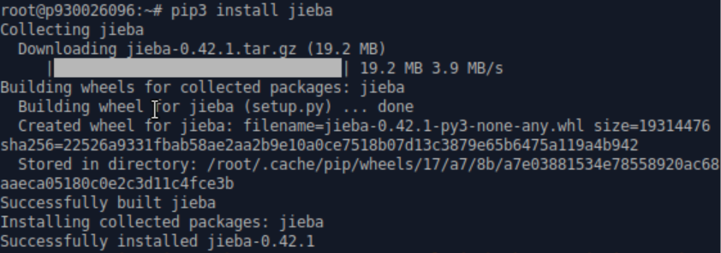

Install jieba in anaconda

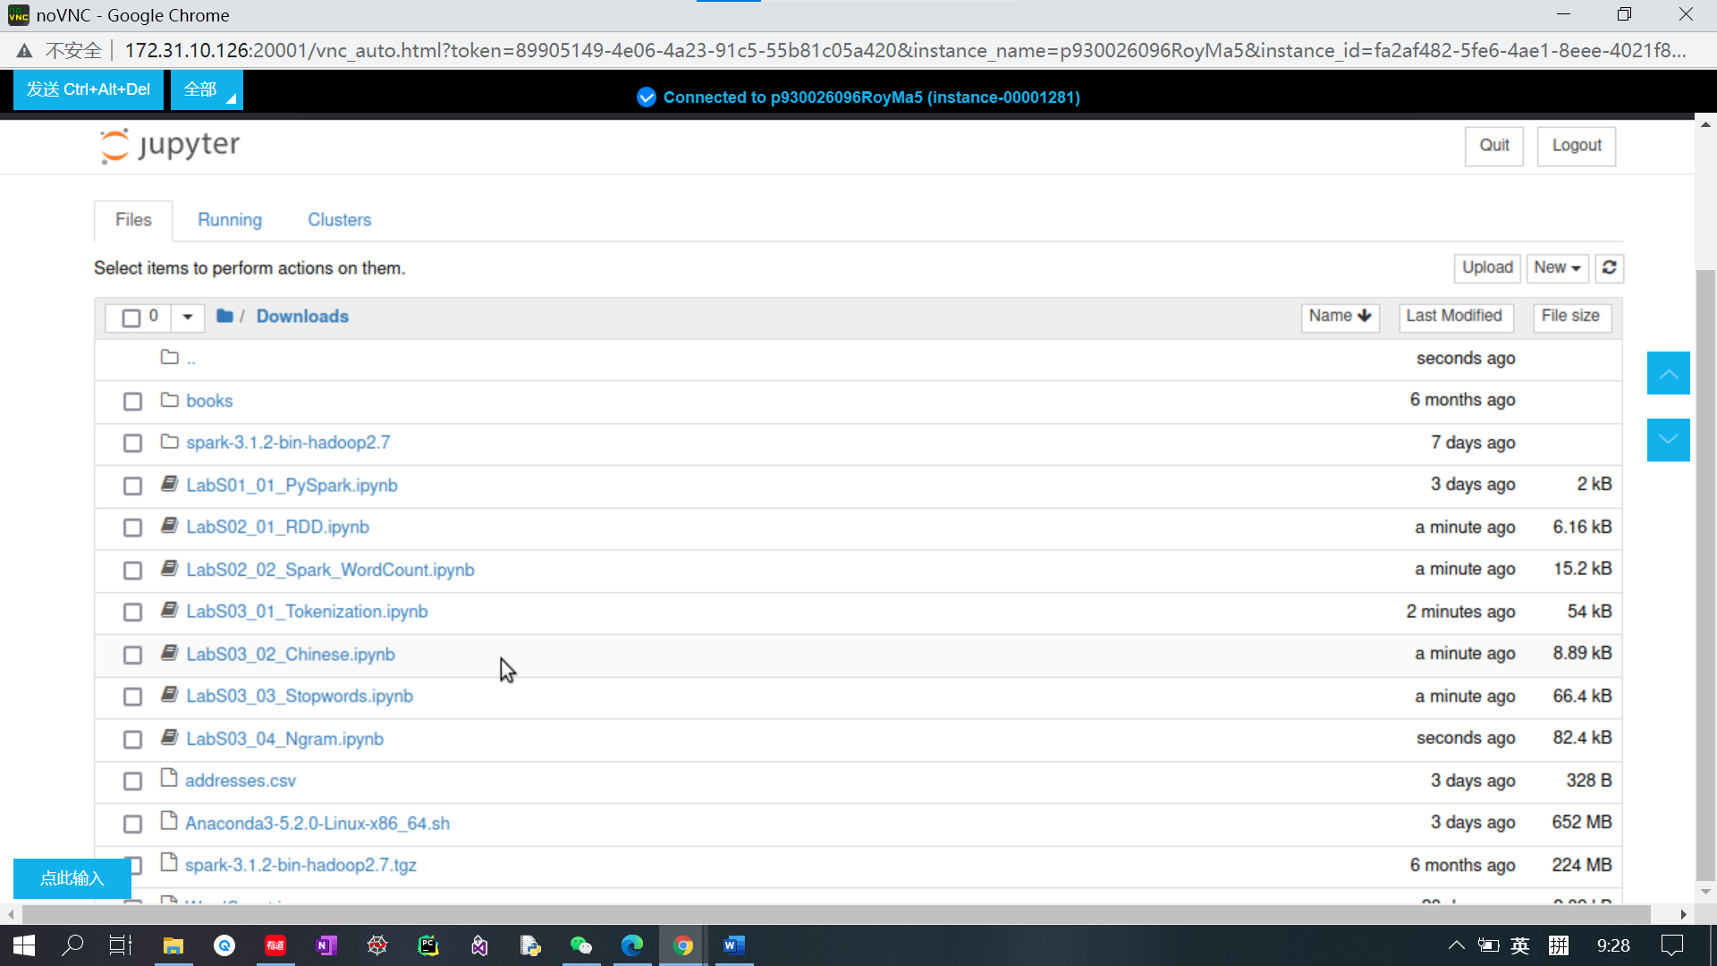

Open the localhost jupyter notebook

Run the LabS03_1_Tokenization file



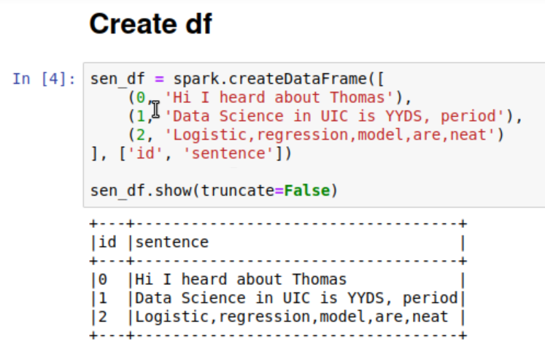

Create spark dataframe

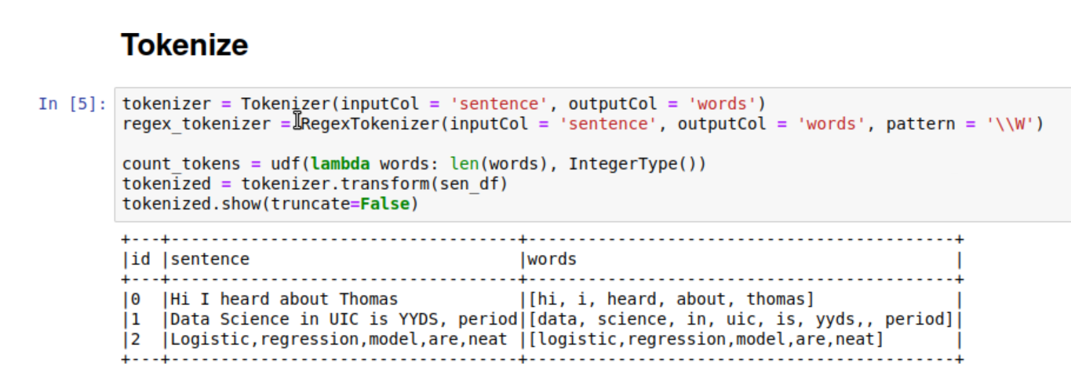

Tokenize the words in sentences

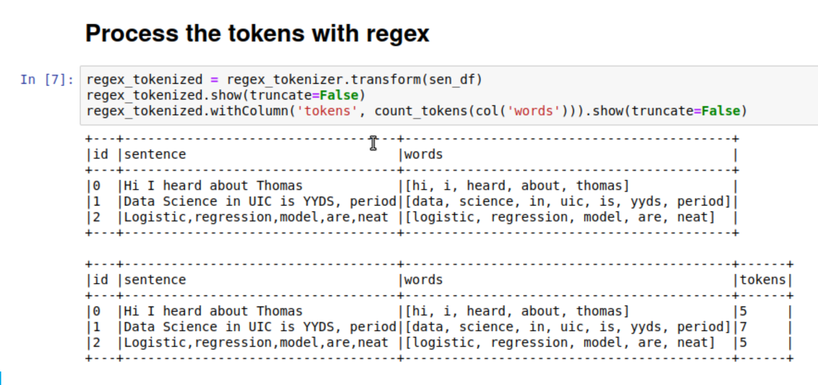

Process the tokens with regex

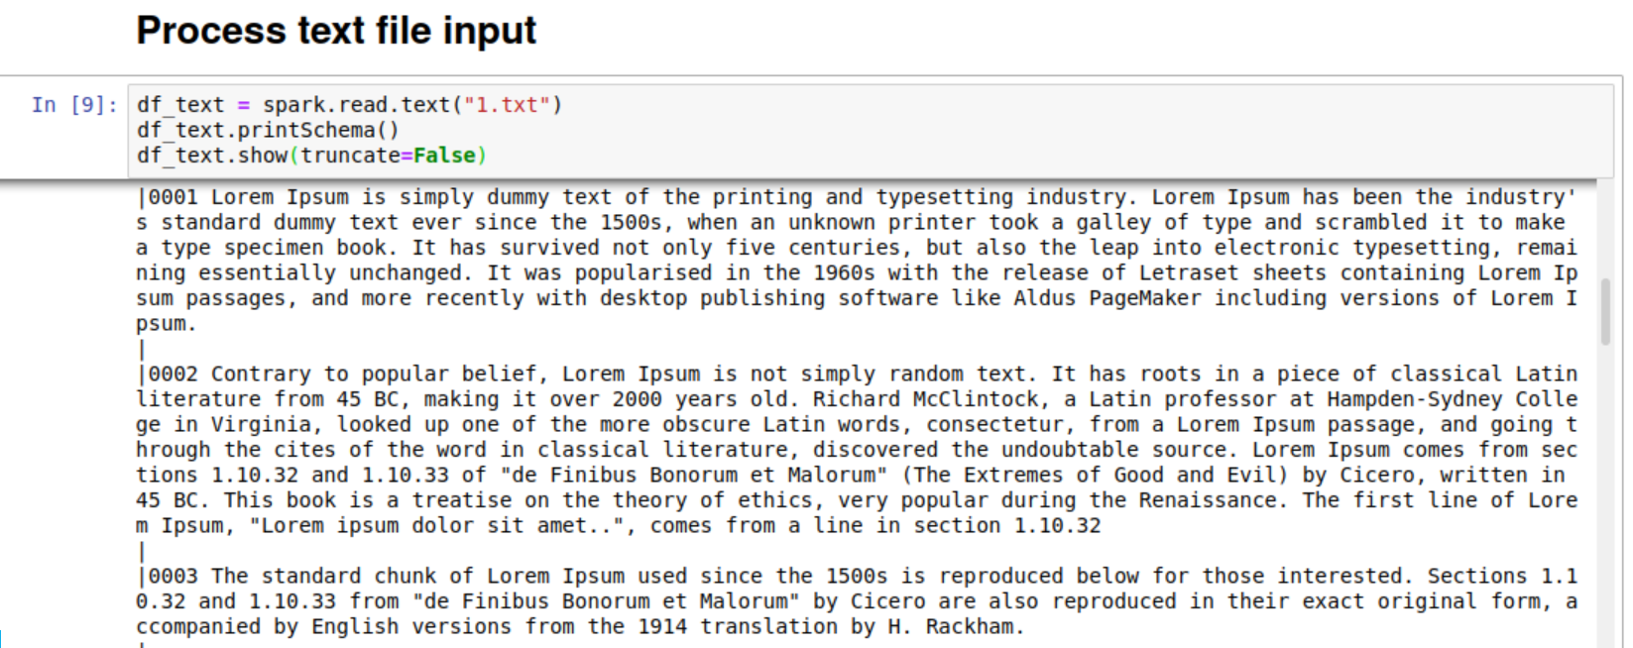

Read a text file

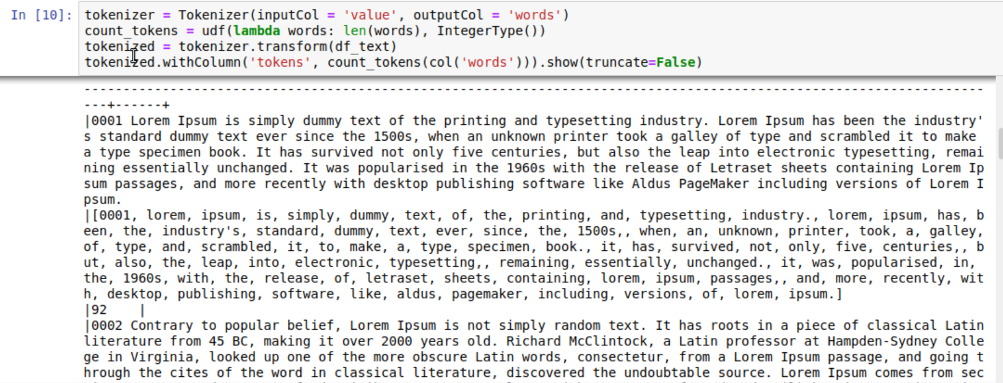

Tokenization for the text file

Run the Lab03_02_Chinese file



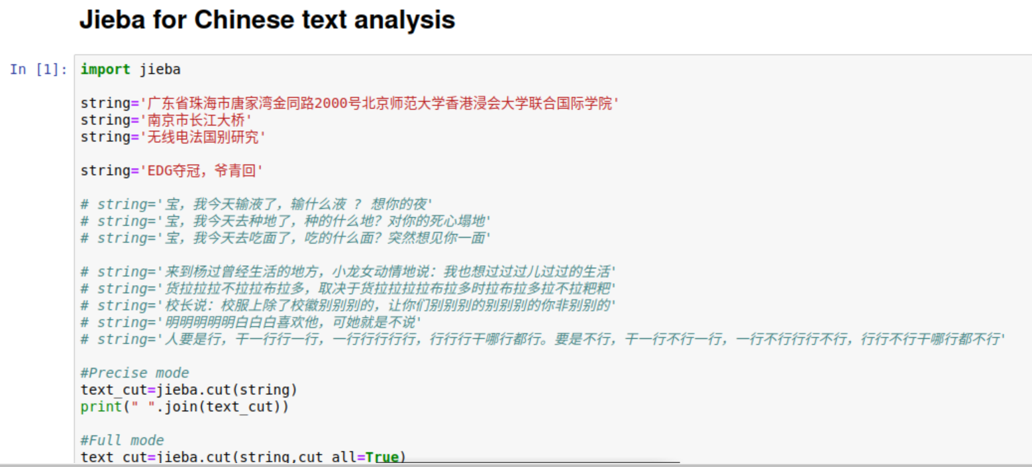

Define some Chinese strings as input

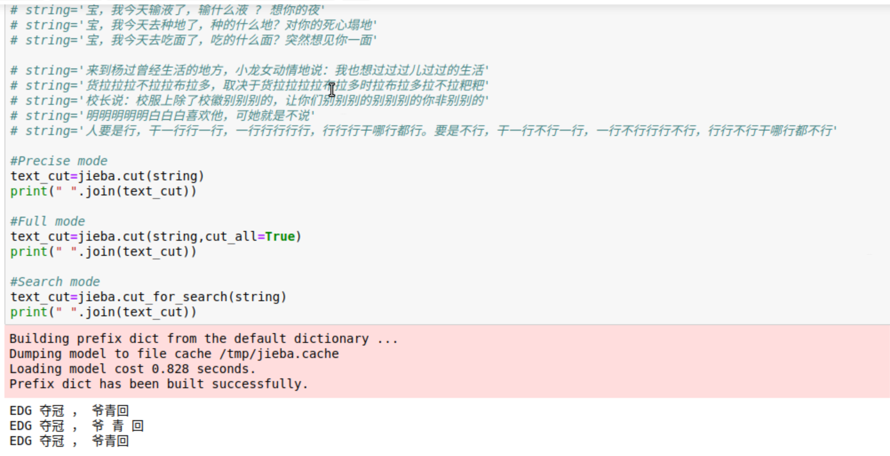

Tokenization of Chinese

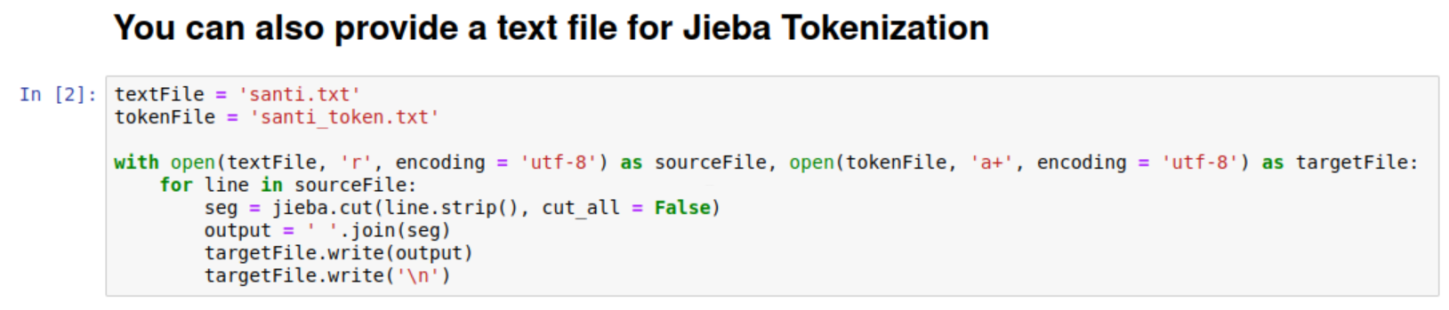

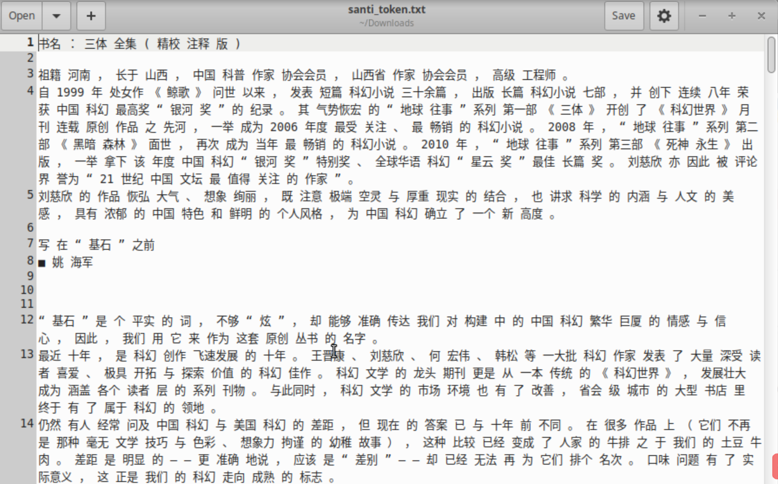

Tokenization for Chinese text file

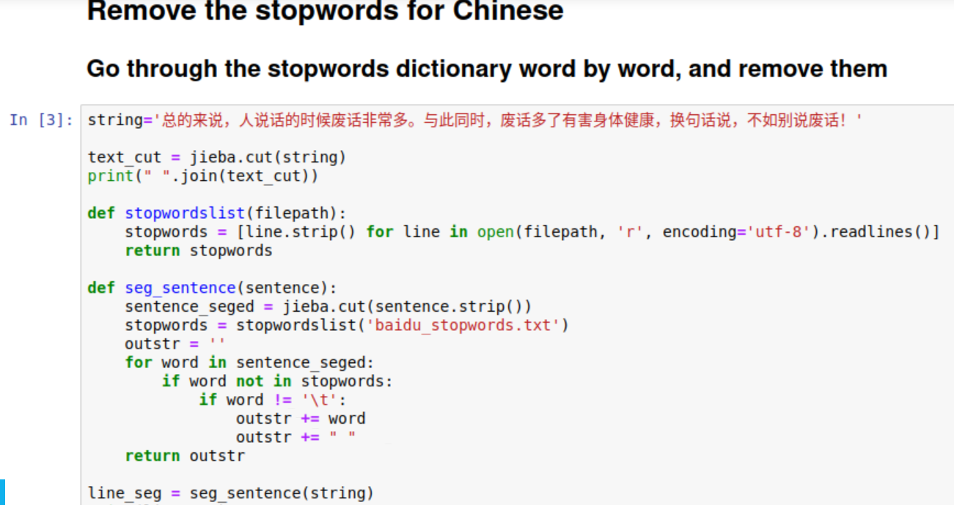



Remove stop words in Chinese text according to baidu_stopwords.txt

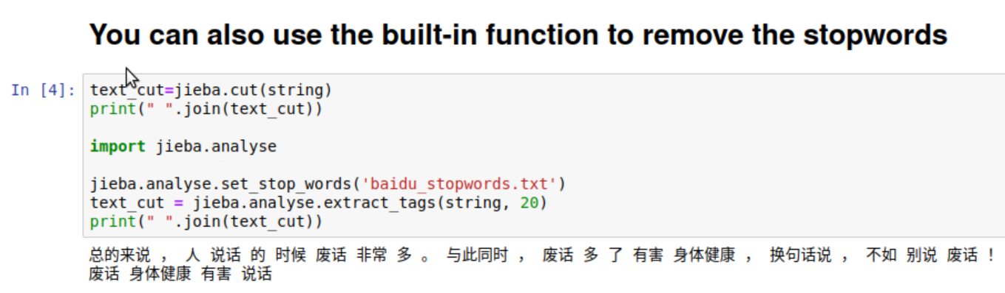

Use a built-in function to remove the stop words rather than using baidu_stopwords.txt

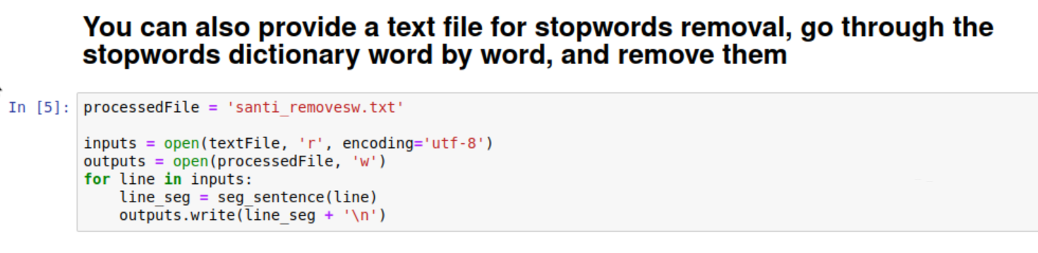

Provide a self-built stop words text file, and remove stop words in the file

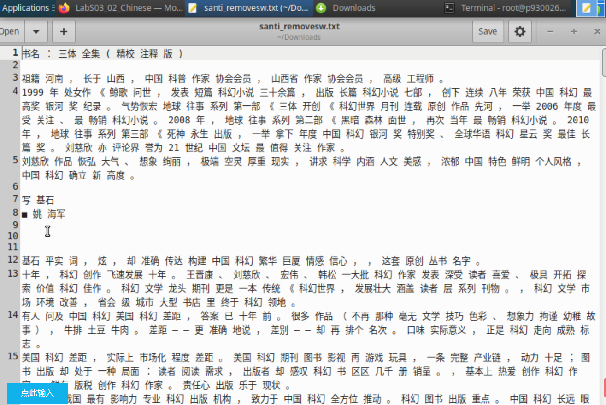

The result of a Chinese text file, removing stop words

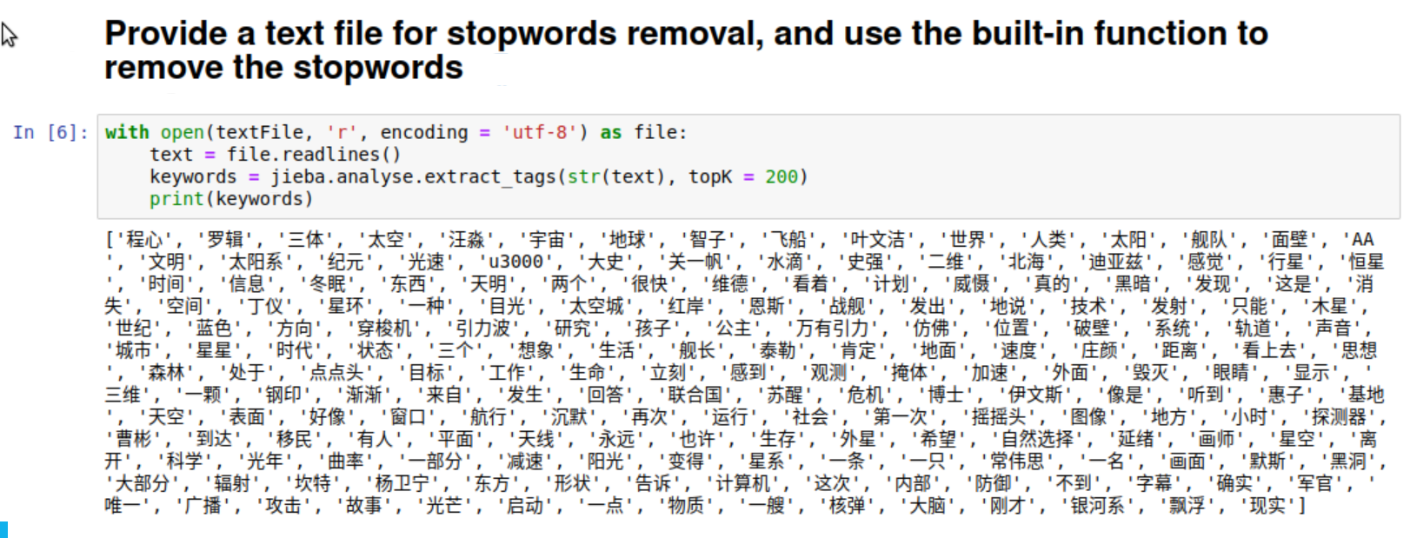

Remove stop words according to your own stop words file.

Run LabS03_03_Stopwords file



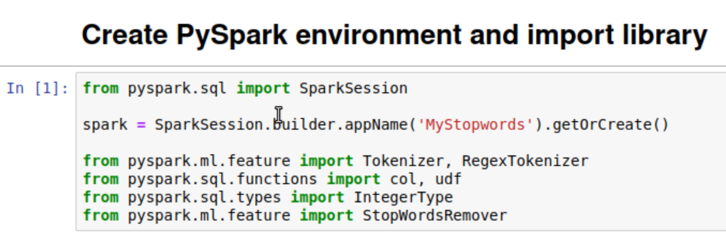

Create pyspark environment and import library

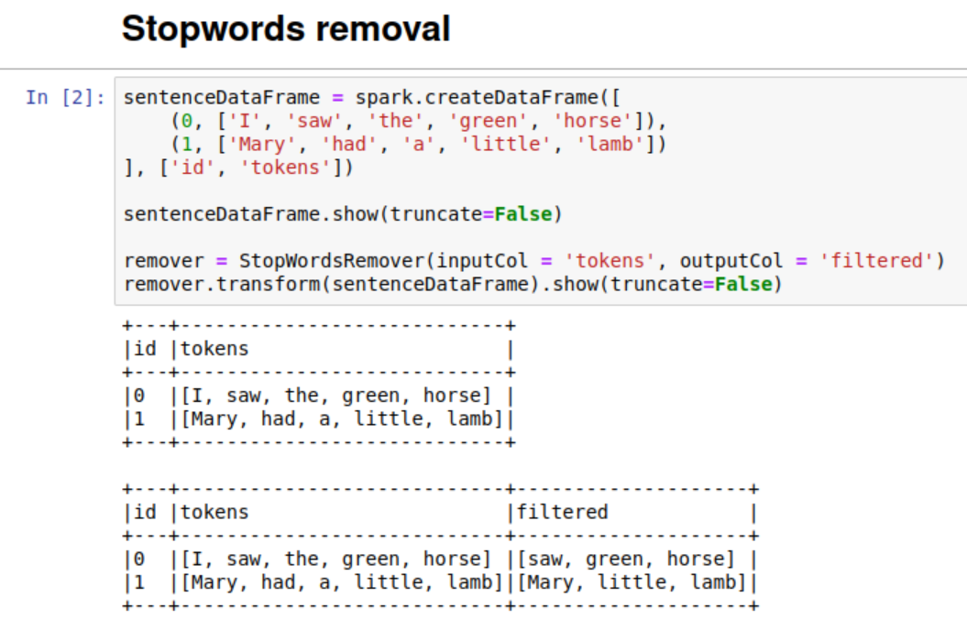

Remove stop words in English sentences by built-in function

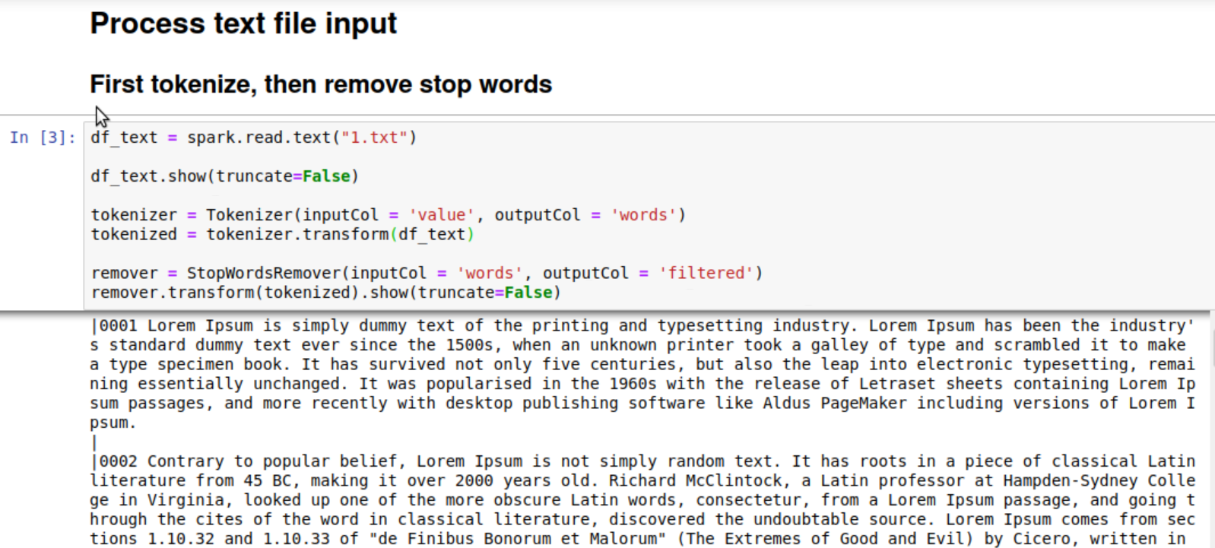

Process text file. First tokenization and then remove stop words

Run LabS03_04_Ngram



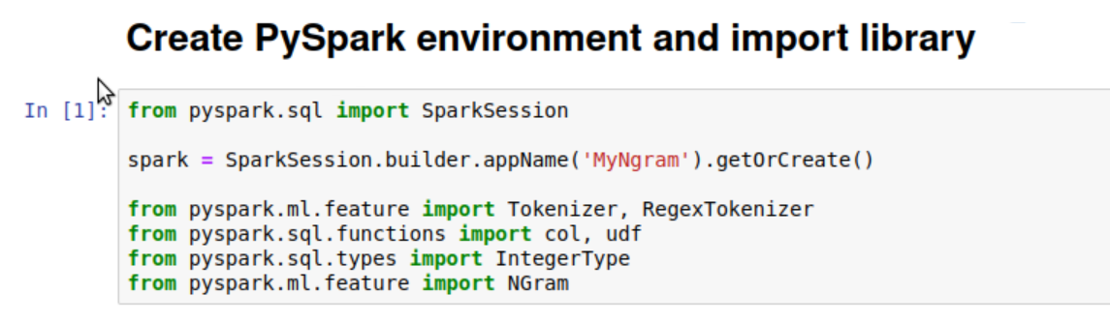

Create pyspark environment and import library

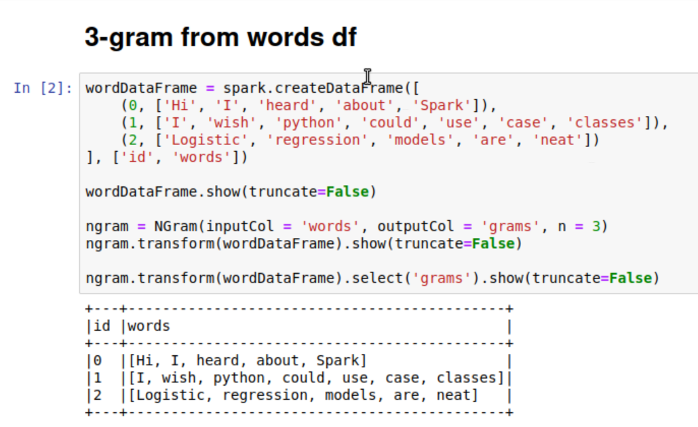

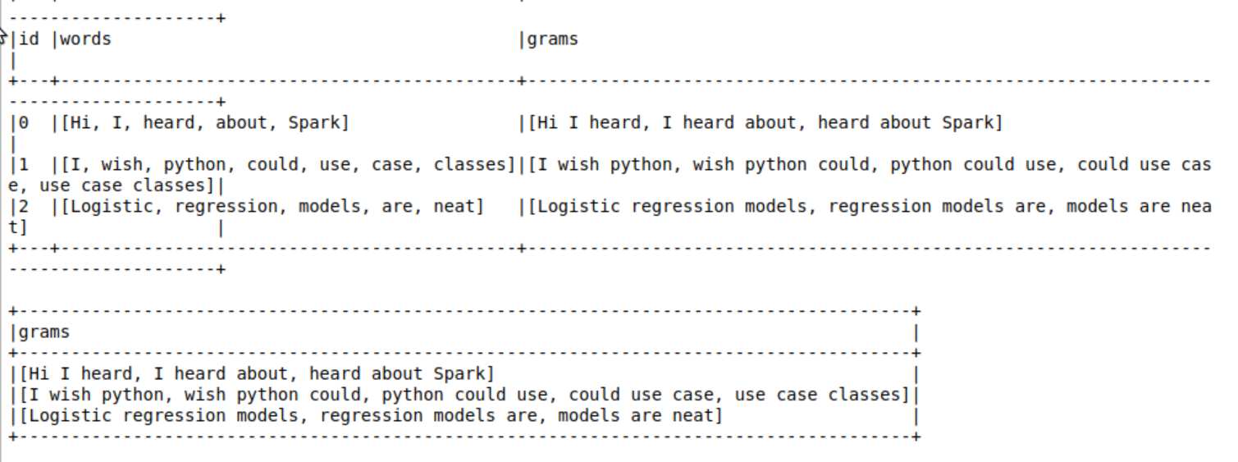

Get 3-gram from words df

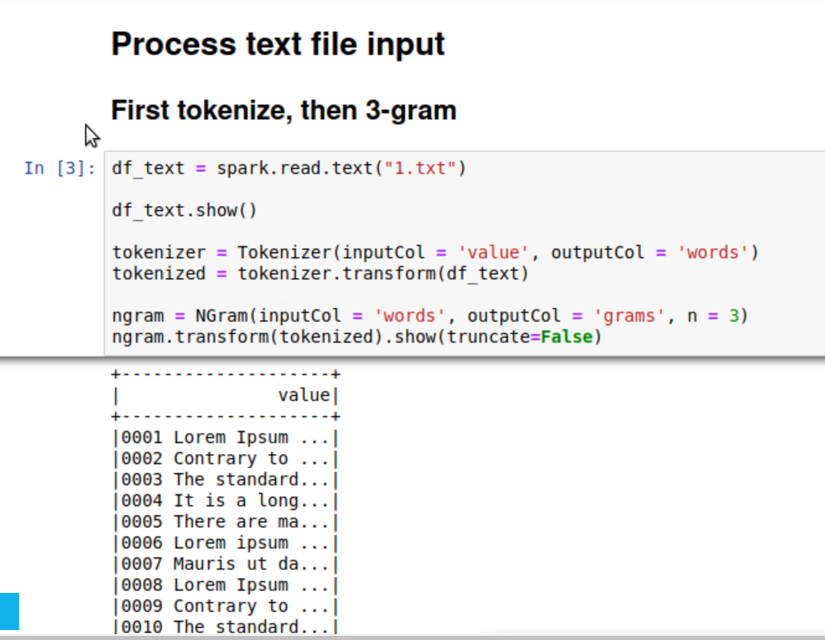

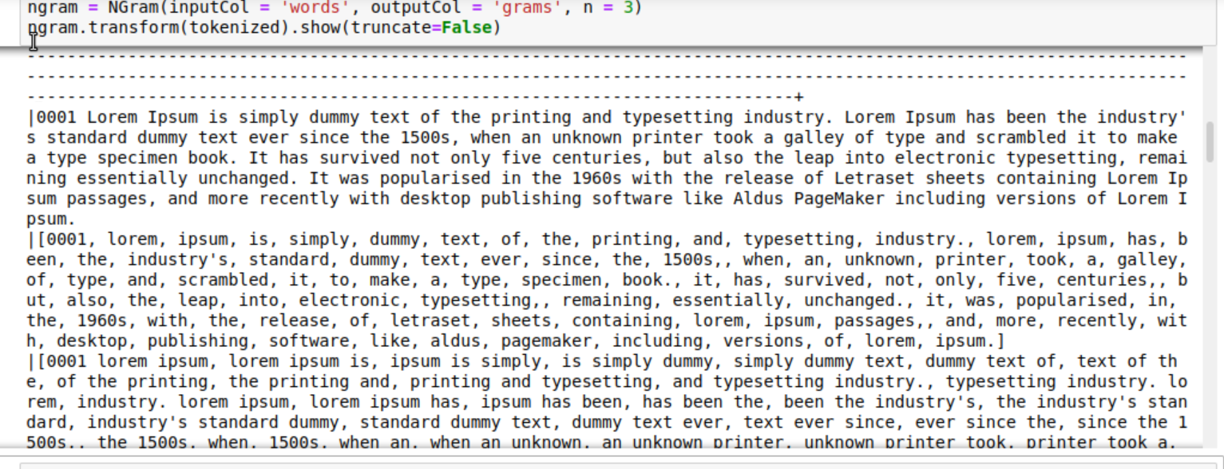

Process text file. First tokenization and then get 3-gram

Run LabS02_01_RDD file



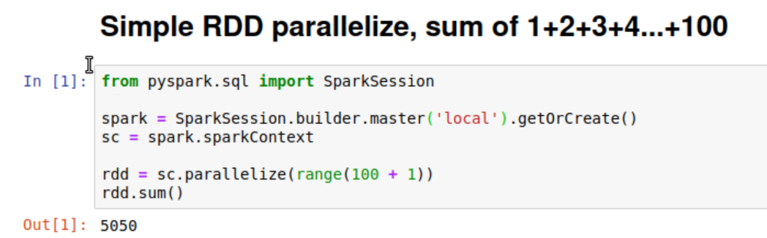

Try RDD parallelize. Get the sum from 1 to 100

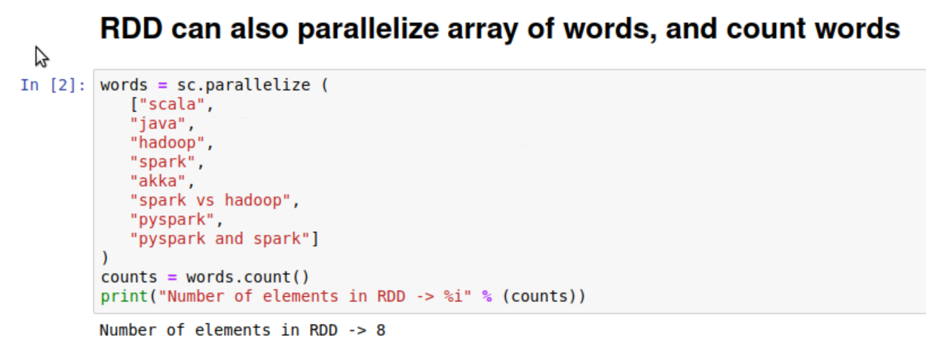

RDD can also parallelize array of words, and count words

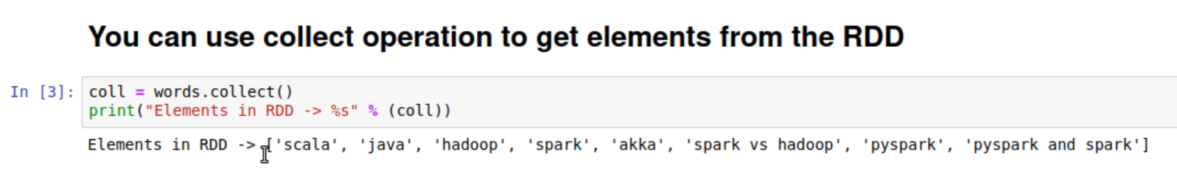

Get elements from RDD by .collect() function

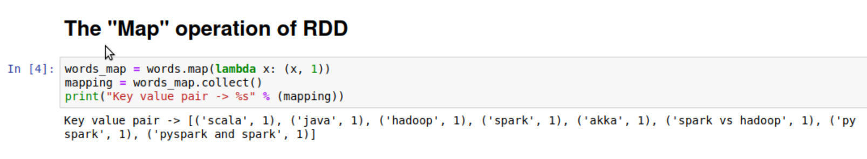

Map elements from RDD by .map() function

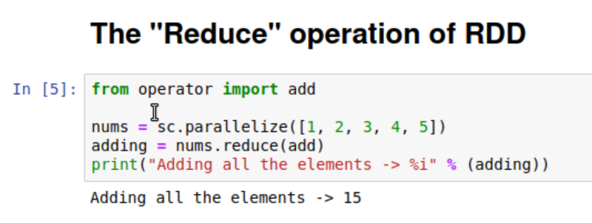

Aggregate the elements of the dataset by .reduce() function

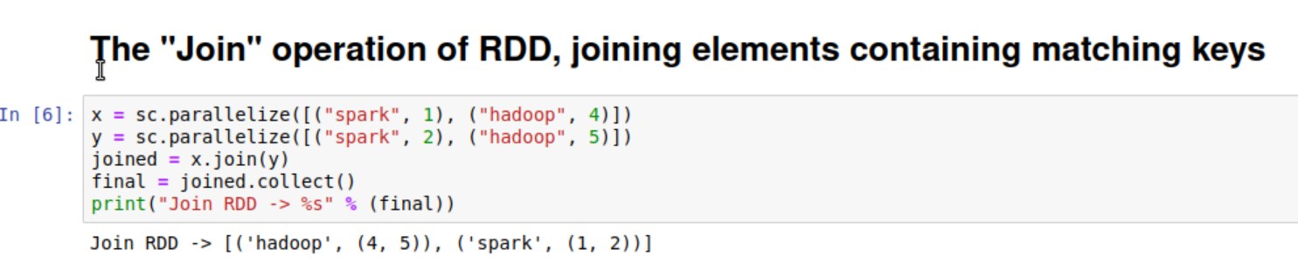

Join elements containing matching keys by .join function

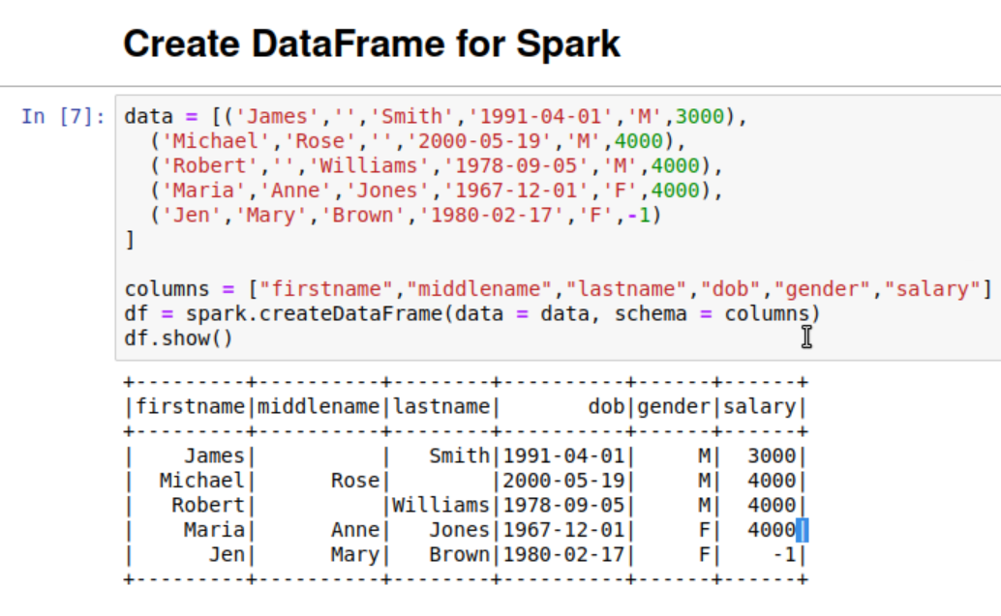

Create dataframe for spark

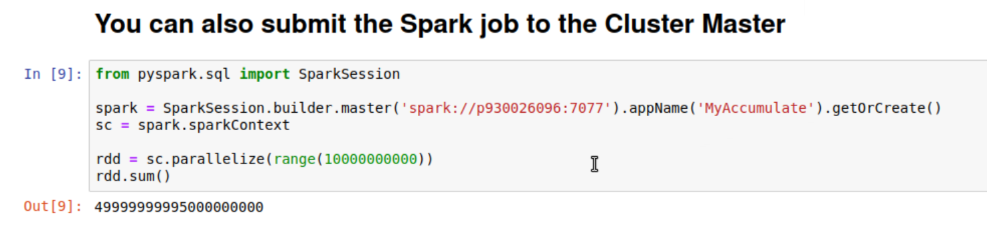

Use master and two workers to calculate a very large number

Run LabS02_02_Spark_WordCount file



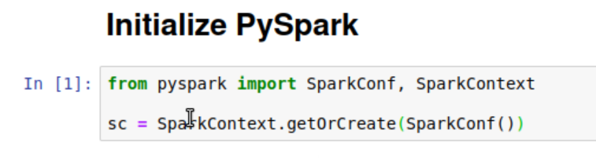

Initialize pyspark

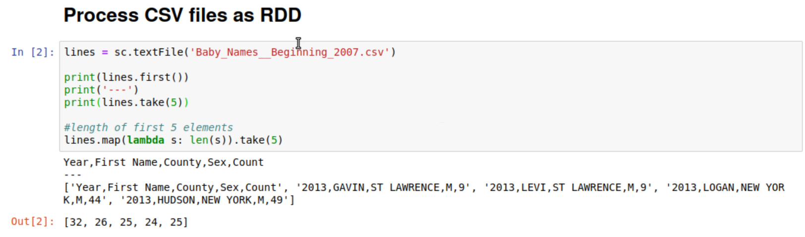

Run .csv file as RDD

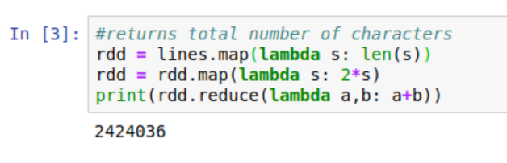

Apply map and reduce functions.

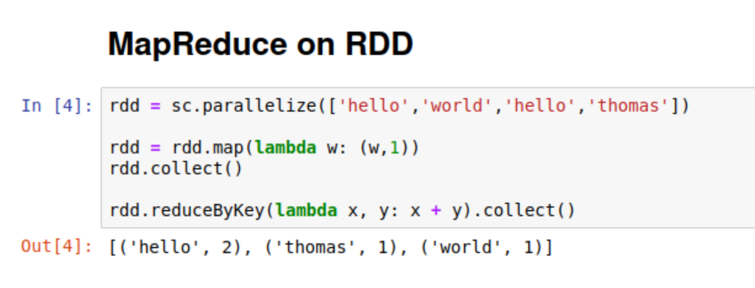

MapReduce on RDD

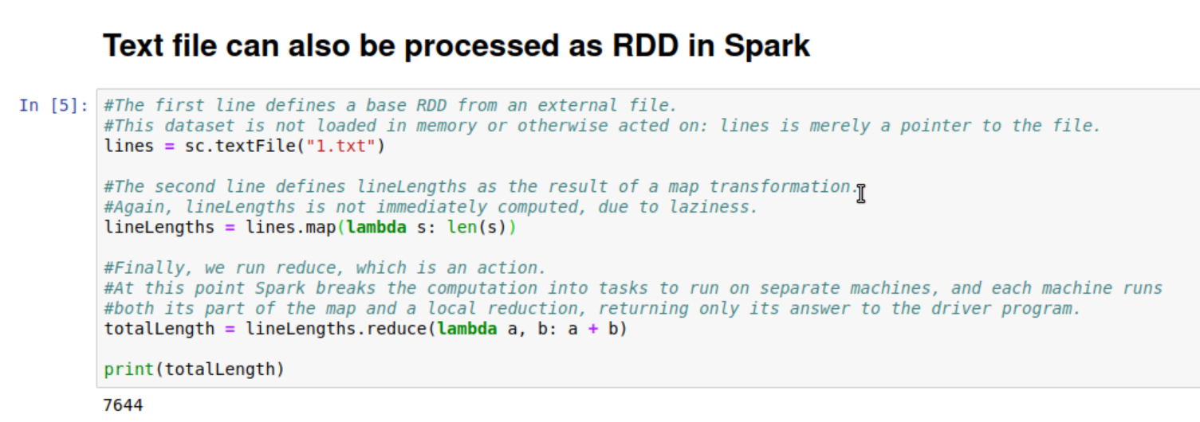

Process text file as RDD in spark

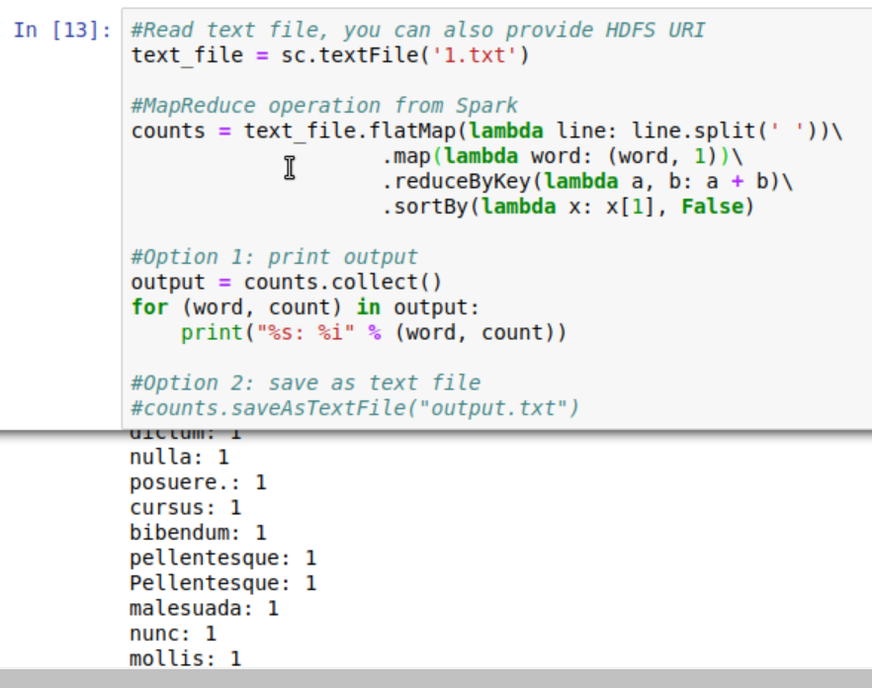

Read a text file and count the word in the document

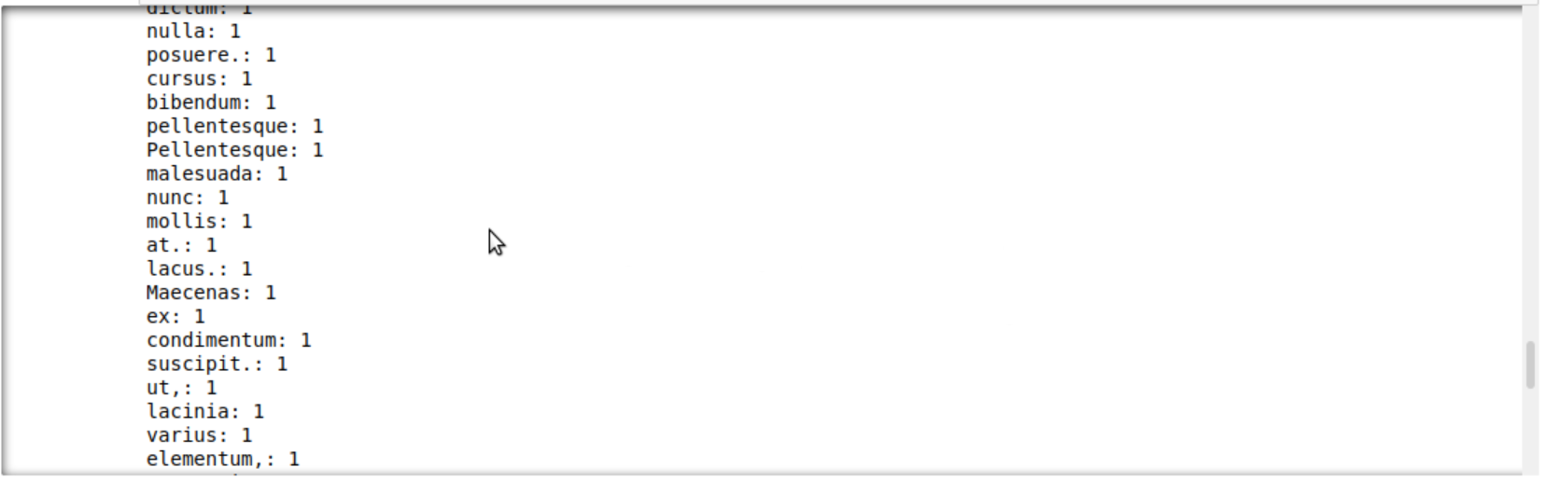

Here is part of the word count result

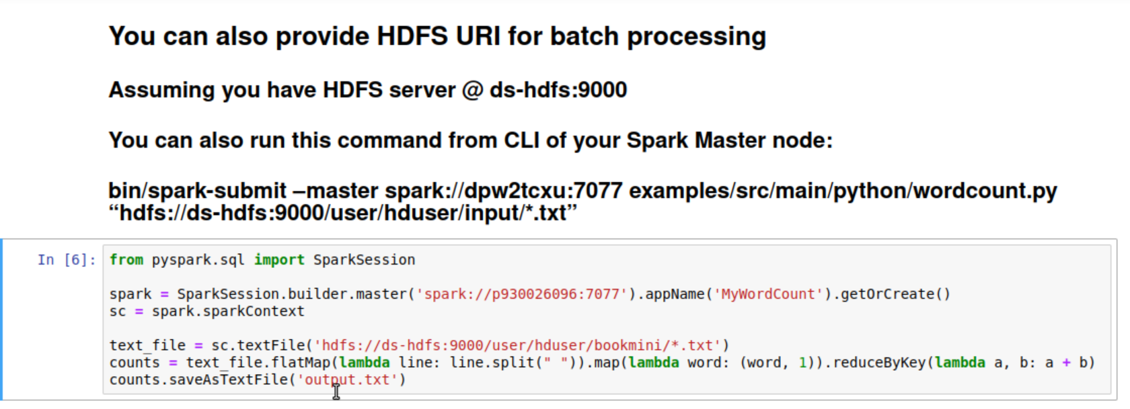

Indicating the HDFS URL. Attach files in HDFS as the input text files to apply word count to every file in bookmini directory

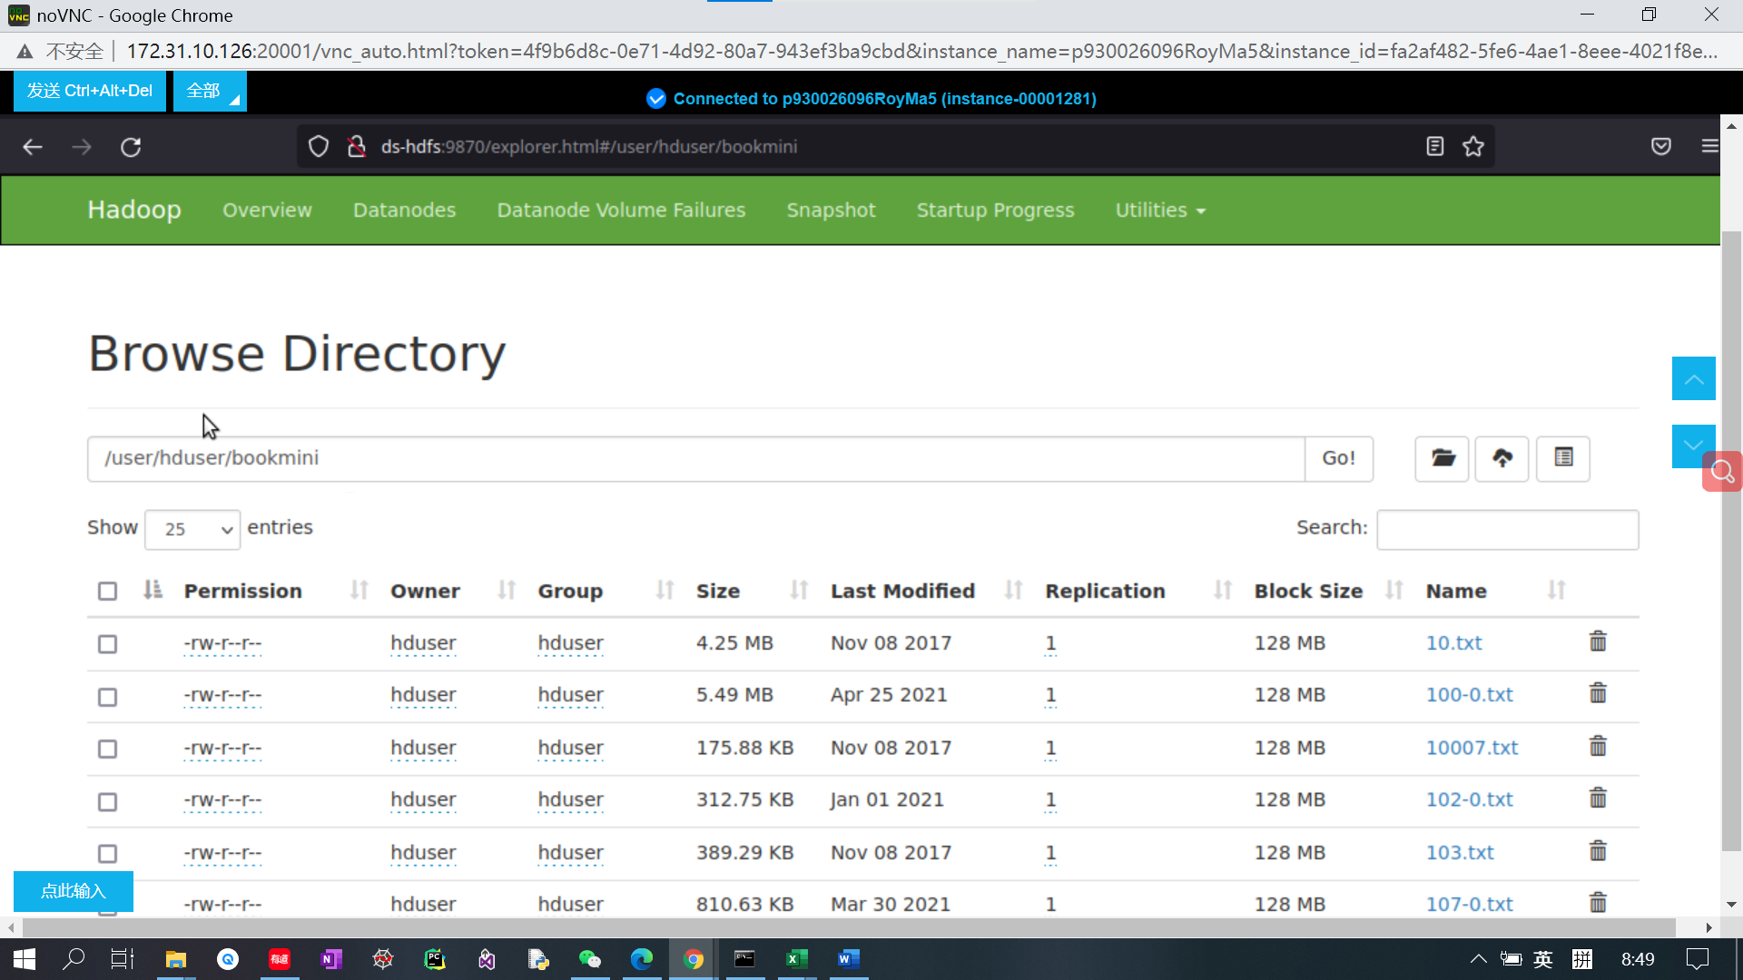

The books in bookmini directory

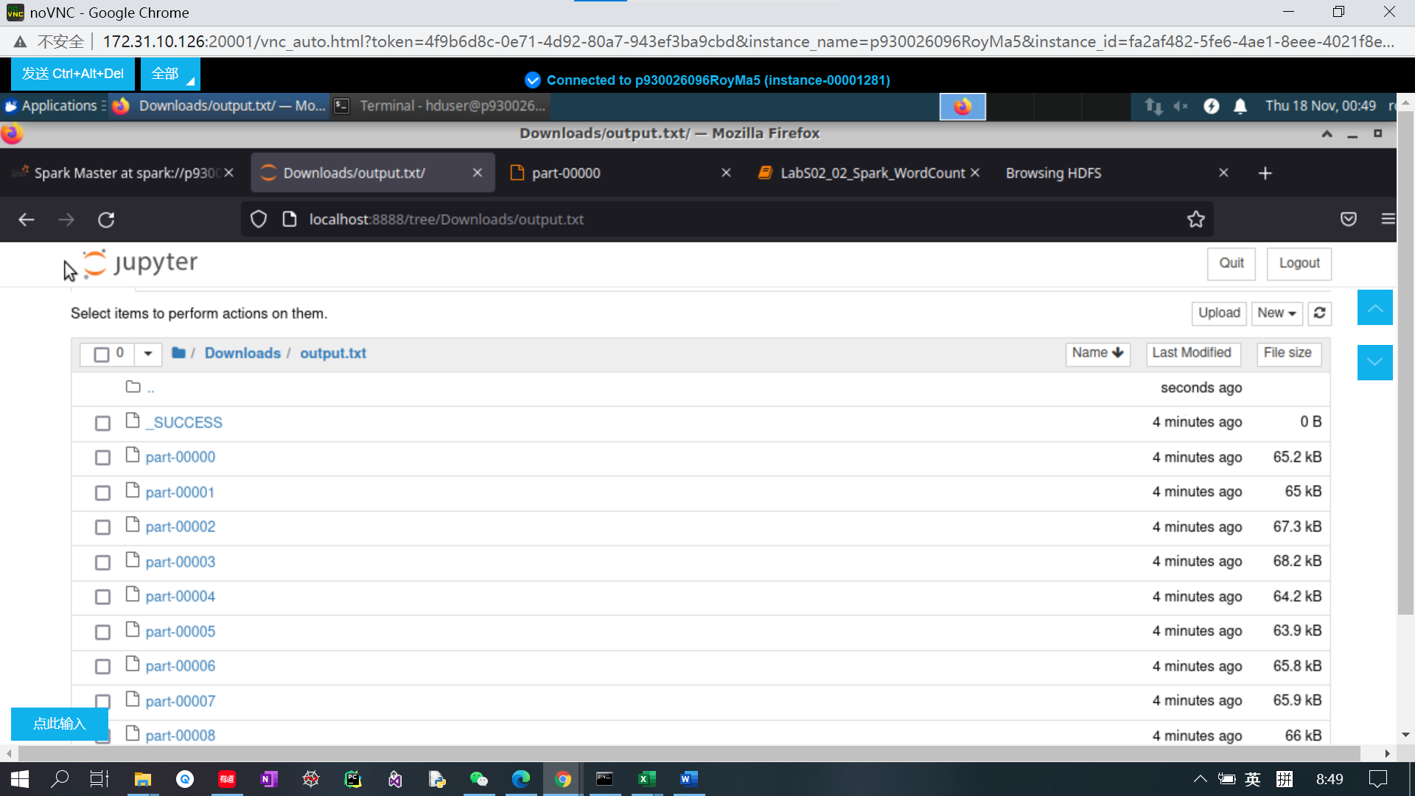

The output file. Each file contains corresponding word count result

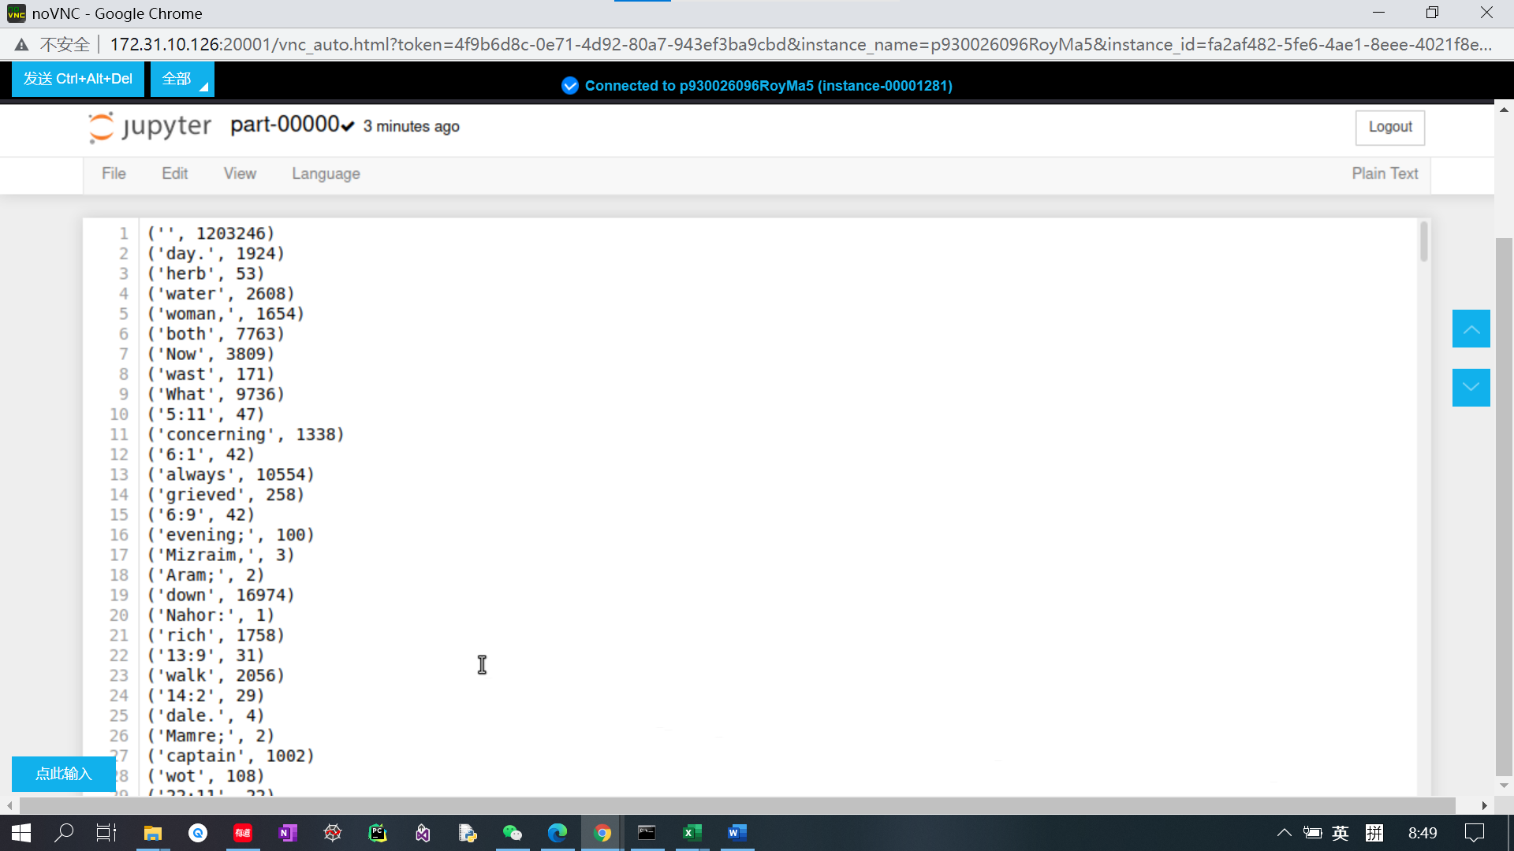

We open the first result file as an example.